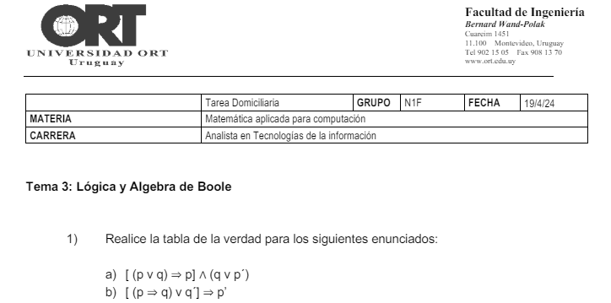

1.a)

| p | q | p` | (p v q) | [ (p v q) => p ] | (q v p`) | [ (p v q) => p ] ^ (q v p`) |
| --- | --- | --- | --- | --- | --- | --- |
| 0 | 0 | 1 | 0 | 1 | 1 | 1 |
| 0 | 1 | 1 | 1 | 0 | 1 | 0 |
| 1 | 0 | 0 | 1 | 1 | 0 | 0 |
| 1 | 1 | 0 | 1 | 1 | 1 | 1 |

1.b)

| p | q | q´ | p´ | (p=>q) | (p=>q)vq´ | [(p=>q)vq´] => p´ |
| --- | --- | --- | --- | --- | --- | --- |
| 0 | 0 | 1 | 1 | 1 | 1 | 1 |
| 0 | 1 | 0 | 1 | 1 | 1 | 1 |
| 1 | 0 | 1 | 0 | 0 | 1 | 0 |
| 1 | 1 | 0 | 0 | 1 | 1 | 0 |

2)

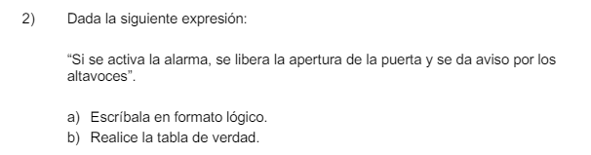

“Si **se activa la alarma**, **se libera la apertura de la puerta** y **se da aviso por los altavoces**”

p = se activa la alarma

q = se libera la apertura de la puerta

r = se da aviso por los altavoces.

p => (q ^ r)

| p | q | r | (q ^ r) | p => (q ^ r) |
| --- | --- | --- | --- | --- |
| 0 | 0 | 0 | 0 | 1 |
| 0 | 0 | 1 | 0 | 1 |
| 0 | 1 | 0 | 0 | 1 |
| 0 | 1 | 1 | 1 | 1 |
| 1 | 0 | 0 | 0 | 0 |
| 1 | 0 | 1 | 0 | 0 |
| 1 | 1 | 0 | 0 | 0 |
| 1 | 1 | 1 | 1 | 1 |